

Year 11 Integrated Science

Unit 1 Semester 1 2023

**Earth Systems and Ecosystems Test**

Student Name: ______________________________

Assessment Date:

**TOTAL MARKS**

**/40**

Working time: 50 minutes

Weighting: 5%

Teacher Comments:

**You should answer ALL of the questions and show full working.**

**Must be completed under test conditions.**

**SECTION A: MULTIPLE CHOICE**

1. Which of these is not an environmental problem facing the world today?
   1. Running out of clean drinking water
   2. Deforestation and the reduction in habitats for wild animals
   3. Running out of solar energy
   4. Increasing global temperatures due to global warming
2. Which of the following is an example of recycling?
   1. Donating furniture to charity
   2. Melting used aluminium cans to make new products
   3. Saving left over food in plastic containers
   4. Selling used clothing at a garage sale
3. Whose responsibility is it to protect the environment?
   1. The government
   2. Individuals
   3. Corporations
   4. All of the above
4. Which of these is not an effect of global warming?
   1. Rising sea levels
   2. Melting polar ice
   3. Melting of glaciers
   4. More hours of sunlight
5. Which of these describes an interaction between two different spheres of the Earth?
   1. A fox eating a rabbit
   2. Hot air rising and cold air sinking
   3. The water in a river eroding a rock
   4. A volcanic eruption causing an earthquake
6. Which of the following is not a natural resource?
   1. Freshwater
   2. Petroleum
   3. Polyester
   4. Timber and wood products
7. The conservation of matter occurs in cycles in nature. Which of the following is an example of a cyclic natural process?
   1. Carbon dioxide moving between the atmosphere and the oceans
   2. Mining of minerals for industrial use
   3. Deforestation leading to soil erosion
   4. Release of pollutants into rivers and waterways

**SECTION B: SHORT RESPONSE**

**Question 8** (4 marks)

List the four Earth’s spheres and give an example of each.

|  |  |
| --- | --- |
| **Sphere** | **Example** |
|  |  |
|  |  |
|  |  |
|  |  |

**Question 9** (4 marks)

Using the diagram below, name the missing parts of the carbon cycle.

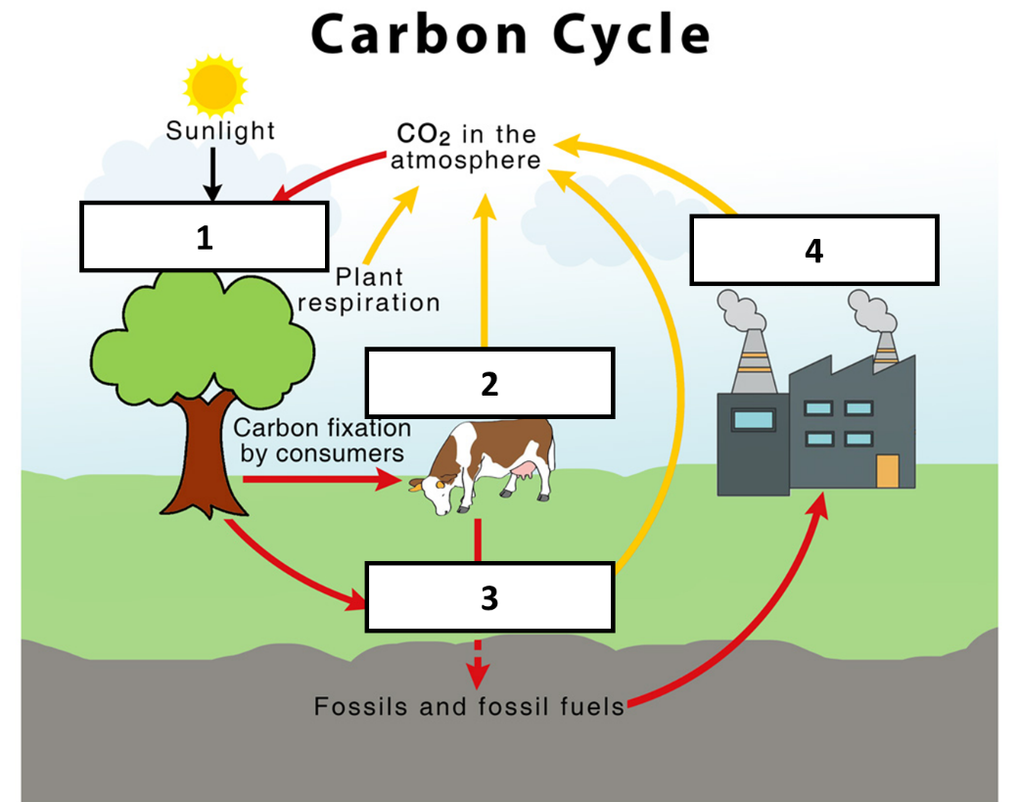

1.

2.

3.

4.

**Question 10** (2 marks)

Describe two pathways that carbon dioxide can take from an animal to the atmosphere.

1.

2.

**Question 11** (3 marks)

Greenhouse gases are important gases that exist in the atmosphere. The Earth, greenhouse gases and radiation from the Sun all interact to maintain the Earth’s temperature. Without these interactions, Earth’s temperature would be about 34oC colder.

With the help of the diagram, complete the steps below to explain how the greenhouse effect maintains the Earth’s temperature.

1. ***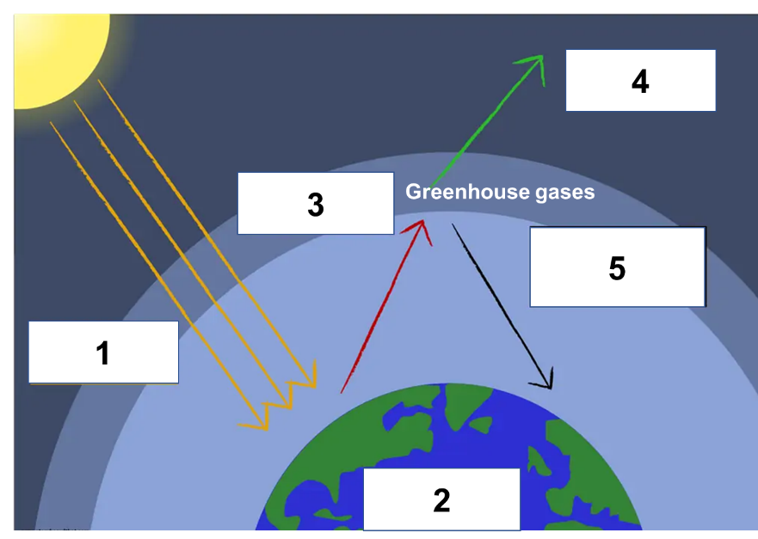****Ultraviolet radiation and visible light from the Sun enter the atmosphere and reach the Earth.*

2.

3.

4. *Some of the radiation is emitted into space.*

5.

**Question 12** (4 marks)

Unlike fossil fuels, solar energy does not emit carbon dioxide into the atmosphere. Explain in detail why using burning fossil fuels can increase global temperatures but using solar energy does not.

**Question 13** (6 marks)

Individuals, companies and governments all play important roles in reducing the impact of climate change.

List **one** strategy that each of these groups can do and explain how this can help reduce the impact of global warming and climate change.

|  |  |  |
| --- | --- | --- |
| **Group** | **Strategy** | **Why this can help** |
| Individuals |  |  |
| Companies |  |  |
| Governments |  |  |

**Question 14** (10 marks)

Over the past several decades, average temperatures in Australia have increased due to global warming. Researchers wanted to study whether this increase in temperature was changing the physical and biological characteristics of native species. They measured the average body mass of adult short-beaked echidnas (Tachyglossus aculeatus) in the Southwest Australia region.

The data for these observations is provided in the table below.

|  |  |
| --- | --- |
| **Average temperature**  **(oC)** | **Average body mass**  **(kg)** |
| 22.1 | 6.0 |
| 22.4 | 5.9 |
| 22.7 | 5.7 |
| 23.1 | 5.5 |
| 23.4 | 5.2 |

1. What is the independent variable in this experiment? [1]
2. What is the dependent variable in this experiment? [1]
3. Identify a controlled variable in this experiment. [1]
4. Write a hypothesis for the experiment. [1]
5. Plot the data on the grid provided. [4]
6. Describe the relationship observed between the average temperature and the average body mass of the echidnas. [2]

23.4

23.2

22.0

22.2

22.4

22.6

22.8

( )

5

5.2

5.4

5.6

5.8

6

6.2

|  |  |  |  |  |  |  |  |  |  |  |  |  |  |  |  |  |  |  |  |  |  |  |  |  |  |  |  |  |  |  |  |  |  |  |  |  |  |  |  |
| --- | --- | --- | --- | --- | --- | --- | --- | --- | --- | --- | --- | --- | --- | --- | --- | --- | --- | --- | --- | --- | --- | --- | --- | --- | --- | --- | --- | --- | --- | --- | --- | --- | --- | --- | --- | --- | --- | --- | --- |
|  |  |  |  |  |  |  |  |  |  |  |  |  |  |  |  |  |  |  |  |  |  |  |  |  |  |  |  |  |  |  |  |  |  |  |  |  |  |  |  |
|  |  |  |  |  |  |  |  |  |  |  |  |  |  |  |  |  |  |  |  |  |  |  |  |  |  |  |  |  |  |  |  |  |  |  |  |  |  |  |  |
|  |  |  |  |  |  |  |  |  |  |  |  |  |  |  |  |  |  |  |  |  |  |  |  |  |  |  |  |  |  |  |  |  |  |  |  |  |  |  |  |
|  |  |  |  |  |  |  |  |  |  |  |  |  |  |  |  |  |  |  |  |  |  |  |  |  |  |  |  |  |  |  |  |  |  |  |  |  |  |  |  |
|  |  |  |  |  |  |  |  |  |  |  |  |  |  |  |  |  |  |  |  |  |  |  |  |  |  |  |  |  |  |  |  |  |  |  |  |  |  |  |  |
|  |  |  |  |  |  |  |  |  |  |  |  |  |  |  |  |  |  |  |  |  |  |  |  |  |  |  |  |  |  |  |  |  |  |  |  |  |  |  |  |
|  |  |  |  |  |  |  |  |  |  |  |  |  |  |  |  |  |  |  |  |  |  |  |  |  |  |  |  |  |  |  |  |  |  |  |  |  |  |  |  |
|  |  |  |  |  |  |  |  |  |  |  |  |  |  |  |  |  |  |  |  |  |  |  |  |  |  |  |  |  |  |  |  |  |  |  |  |  |  |  |  |
|  |  |  |  |  |  |  |  |  |  |  |  |  |  |  |  |  |  |  |  |  |  |  |  |  |  |  |  |  |  |  |  |  |  |  |  |  |  |  |  |
|  |  |  |  |  |  |  |  |  |  |  |  |  |  |  |  |  |  |  |  |  |  |  |  |  |  |  |  |  |  |  |  |  |  |  |  |  |  |  |  |
|  |  |  |  |  |  |  |  |  |  |  |  |  |  |  |  |  |  |  |  |  |  |  |  |  |  |  |  |  |  |  |  |  |  |  |  |  |  |  |  |
|  |  |  |  |  |  |  |  |  |  |  |  |  |  |  |  |  |  |  |  |  |  |  |  |  |  |  |  |  |  |  |  |  |  |  |  |  |  |  |  |
|  |  |  |  |  |  |  |  |  |  |  |  |  |  |  |  |  |  |  |  |  |  |  |  |  |  |  |  |  |  |  |  |  |  |  |  |  |  |  |  |
|  |  |  |  |  |  |  |  |  |  |  |  |  |  |  |  |  |  |  |  |  |  |  |  |  |  |  |  |  |  |  |  |  |  |  |  |  |  |  |  |
|  |  |  |  |  |  |  |  |  |  |  |  |  |  |  |  |  |  |  |  |  |  |  |  |  |  |  |  |  |  |  |  |  |  |  |  |  |  |  |  |
|  |  |  |  |  |  |  |  |  |  |  |  |  |  |  |  |  |  |  |  |  |  |  |  |  |  |  |  |  |  |  |  |  |  |  |  |  |  |  |  |
|  |  |  |  |  |  |  |  |  |  |  |  |  |  |  |  |  |  |  |  |  |  |  |  |  |  |  |  |  |  |  |  |  |  |  |  |  |  |  |  |
|  |  |  |  |  |  |  |  |  |  |  |  |  |  |  |  |  |  |  |  |  |  |  |  |  |  |  |  |  |  |  |  |  |  |  |  |  |  |  |  |
|  |  |  |  |  |  |  |  |  |  |  |  |  |  |  |  |  |  |  |  |  |  |  |  |  |  |  |  |  |  |  |  |  |  |  |  |  |  |  |  |
|  |  |  |  |  |  |  |  |  |  |  |  |  |  |  |  |  |  |  |  |  |  |  |  |  |  |  |  |  |  |  |  |  |  |  |  |  |  |  |  |
|  |  |  |  |  |  |  |  |  |  |  |  |  |  |  |  |  |  |  |  |  |  |  |  |  |  |  |  |  |  |  |  |  |  |  |  |  |  |  |  |
|  |  |  |  |  |  |  |  |  |  |  |  |  |  |  |  |  |  |  |  |  |  |  |  |  |  |  |  |  |  |  |  |  |  |  |  |  |  |  |  |
|  |  |  |  |  |  |  |  |  |  |  |  |  |  |  |  |  |  |  |  |  |  |  |  |  |  |  |  |  |  |  |  |  |  |  |  |  |  |  |  |
|  |  |  |  |  |  |  |  |  |  |  |  |  |  |  |  |  |  |  |  |  |  |  |  |  |  |  |  |  |  |  |  |  |  |  |  |  |  |  |  |
|  |  |  |  |  |  |  |  |  |  |  |  |  |  |  |  |  |  |  |  |  |  |  |  |  |  |  |  |  |  |  |  |  |  |  |  |  |  |  |  |
|  |  |  |  |  |  |  |  |  |  |  |  |  |  |  |  |  |  |  |  |  |  |  |  |  |  |  |  |  |  |  |  |  |  |  |  |  |  |  |  |
|  |  |  |  |  |  |  |  |  |  |  |  |  |  |  |  |  |  |  |  |  |  |  |  |  |  |  |  |  |  |  |  |  |  |  |  |  |  |  |  |
|  |  |  |  |  |  |  |  |  |  |  |  |  |  |  |  |  |  |  |  |  |  |  |  |  |  |  |  |  |  |  |  |  |  |  |  |  |  |  |  |
|  |  |  |  |  |  |  |  |  |  |  |  |  |  |  |  |  |  |  |  |  |  |  |  |  |  |  |  |  |  |  |  |  |  |  |  |  |  |  |  |
|  |  |  |  |  |  |  |  |  |  |  |  |  |  |  |  |  |  |  |  |  |  |  |  |  |  |  |  |  |  |  |  |  |  |  |  |  |  |  |  |
|  |  |  |  |  |  |  |  |  |  |  |  |  |  |  |  |  |  |  |  |  |  |  |  |  |  |  |  |  |  |  |  |  |  |  |  |  |  |  |  |
|  |  |  |  |  |  |  |  |  |  |  |  |  |  |  |  |  |  |  |  |  |  |  |  |  |  |  |  |  |  |  |  |  |  |  |  |  |  |  |  |
|  |  |  |  |  |  |  |  |  |  |  |  |  |  |  |  |  |  |  |  |  |  |  |  |  |  |  |  |  |  |  |  |  |  |  |  |  |  |  |  |
|  |  |  |  |  |  |  |  |  |  |  |  |  |  |  |  |  |  |  |  |  |  |  |  |  |  |  |  |  |  |  |  |  |  |  |  |  |  |  |  |
|  |  |  |  |  |  |  |  |  |  |  |  |  |  |  |  |  |  |  |  |  |  |  |  |  |  |  |  |  |  |  |  |  |  |  |  |  |  |  |  |
|  |  |  |  |  |  |  |  |  |  |  |  |  |  |  |  |  |  |  |  |  |  |  |  |  |  |  |  |  |  |  |  |  |  |  |  |  |  |  |  |
|  |  |  |  |  |  |  |  |  |  |  |  |  |  |  |  |  |  |  |  |  |  |  |  |  |  |  |  |  |  |  |  |  |  |  |  |  |  |  |  |
|  |  |  |  |  |  |  |  |  |  |  |  |  |  |  |  |  |  |  |  |  |  |  |  |  |  |  |  |  |  |  |  |  |  |  |  |  |  |  |  |
|  |  |  |  |  |  |  |  |  |  |  |  |  |  |  |  |  |  |  |  |  |  |  |  |  |  |  |  |  |  |  |  |  |  |  |  |  |  |  |  |
|  |  |  |  |  |  |  |  |  |  |  |  |  |  |  |  |  |  |  |  |  |  |  |  |  |  |  |  | 23.0 |  |  |  |  |  |  |  |  |  |  |  |

( )